|  |  |  |
| --- | --- | --- |
| **Lyng Primary School P.E Knowledge Organiser** | | |
| **Topic: Football** | Year 6 | Autumn 1 |





**“There is no pressure when you are making a dream come true” – Neymar Jr**

Enquiry Questions

* How can we improve ball control and ability to travel with the ball at speed?
* How can we dribble past an opponent?
* How can different types of control help us in attacking scenarios?
* How can I improve my weaker foot when shooting?
* What pressure should I apply to a player from an attacking team in a defending scenario?
* How can we combine skills we have learnt into game play?

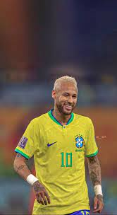 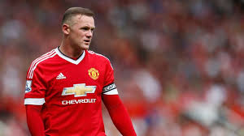



|  |  |
| --- | --- |
| **Key words** | |
| **Spelling** | **Definition** |
| Attacker | Main contribution of an attacker is to focus on creating or taking key opportunities. |
| Offside | When an attacking player is beyond the last defender of the defending team when the ball is passed to them. |
| Dribbling | To move whilst in possession of the ball at your feet. |
| 1-2 | A two pass combination between players to get around a defender. |
| Control | Control could be your first touch when receiving the ball or maintaining control of the ball when dribbling/shooting. |
| Possession | Retain the ball for the team, so your team is in control and have the ball. |
| Indirect free kick | When a free kick is awarded where the attacking team cannot shoot direct at goal another player must make contact with the ball first. |
| Tactics | [Methods](https://www.collinsdictionary.com/dictionary/english/method) that you [choose](https://www.collinsdictionary.com/dictionary/english/choose) in order to be successful, i.e. number of passes made, movement, defensive/offensive shape. |
| Defender | Main contribution to the team is to prevent goals and protect the goalkeeper. |

|  |  |  |
| --- | --- | --- |
| **Lyng Primary School P.E Knowledge Organiser** | | |
| **Topic: Football** | Year 5 | Autumn 1 |

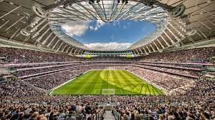 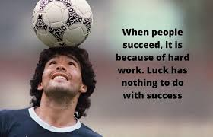

Learning outcomes:

* To develop different types of turns
* To show confidence and put into practice different dribbling techniques
* To show different types of passes and ways to receive the ball
* To develop different shooting styles against an opponent.
* To improve our body shape when defending.
* To combine skills and practices into a game scenario